|  |  |
| --- | --- |
| A picture of a winding road and trees  call of duty  Black ops | Abstract  In the world of "Call of Duty: Black Ops," players and artificial intelligence-controlled enemies engage in a complex dance of actions, reactions, and strategic gameplay. This document explores the key use cases that define these interactions. From navigating the game world to accessing the Enemy AI Behavior Generator Engine, both players and AI entities play pivotal roles. This exploration not only sheds light on the intricate gameplay mechanics but also showcases the unique blend of player agency and AI-driven challenge that defines this iconic gaming experience |

Table of Contents

Call of Duty: Black Ops" is a popular entry in the Call of Duty series, developed by Treyarch and published by Activision. It was first released in November 2010 and is known for its engaging single-player campaign and its contributions to the multiplayer and zombies modes 4

Infinity Ward 4

Treyarch: 4

Sledgehammer Games: 4

Raven Software: 5

Activision: 5

2 Use Case 1: Navigate the Map 5

3 Use Case 2: Play Campaign 5

4 Use Case 3: Play Multiplayer 6

5 Use Case 4: Play Zombies 6

6 Use Case 6: Navigate the Map (Enemy AI) 6

7 Use Case 7: Access Enemy AI Generator Engine 6

8 Use Case 8: Determine Player's Location (Enemy AI) 7

Introduction to application call of duty

Call of Duty is a popular video game franchise known for its first-person shooter (FPS) games. The franchise has numerous titles, each offering a different storyline, setting, and gameplay experience. Call of Duty games are typically set in various historical periods, modern settings, or futuristic environments, and they often feature intense combat and military themes. The games are developed by different studios, including Infinity Ward, Treyarch, Sledgehammer Games, and Raven Software.

Here's a brief introduction to some of the key aspects of the Call of Duty franchise:

1. Gameplay: Call of Duty games primarily focus on fast-paced, action-packed combat. Players take on the role of soldiers or special forces operatives and engage in various military operations, ranging from World War II battles to modern warfare and even science fiction scenarios.
2. Single Player Campaign: Most Call of Duty games include a single-player campaign mode, where players follow a storyline and complete missions. These campaigns often feature cinematic storytelling and character-driven narratives.
3. Multiplayer Mode: Call of Duty is well-known for its online multiplayer modes, allowing players to compete against each other in various game modes, such as Team Deathmatch, Domination, and Search and Destroy. Multiplayer features customizable loadouts, perks, and killstreak rewards.
4. Zombies Mode: Some Call of Duty titles include a Zombies mode, where players team up to survive waves of undead enemies. This mode often has its own storyline and unique gameplay mechanics.
5. Warzone: In recent years, Call of Duty introduced "Warzone," a free-to-play battle royale mode. Warzone is set in a massive open world and combines elements from previous Call of Duty games with the battle royale genre.
6. Cross-Platform Play: Many Call of Duty titles offer cross-platform play, allowing players on different gaming platforms to compete and team up together.
7. Annual Releases: The franchise traditionally releases new titles on an annual basis, with each title offering its own unique take on the series.

It's worth noting that this introduction provides a general overview of the Call of Duty franchise. Specific details and gameplay mechanics can vary from one game to another. If you're interested in a particular Call of Duty game or have more specific questions, please let me know, and I can provide additional information

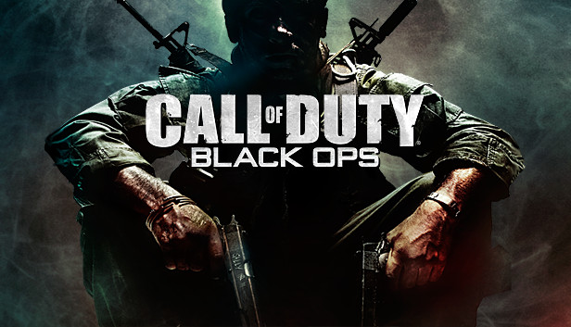

Call of Duty: Black Ops" is a popular entry in the Call of Duty series, developed by Treyarch and published by Activision. It was first released in November 2010 and is known for its engaging single-player campaign and its contributions to the multiplayer and zombies modes

The Call of Duty franchise is developed and published by several well-known companies, with each company responsible for different entries in the series. Here are the main companies associated with Call of Duty:

Infinity Ward: Infinity Ward is one of the original developers of the Call of Duty series and is known for creating the highly successful "Modern Warfare" sub-series. They have developed some of the most iconic titles in the franchise.

Treyarch: Treyarch is another key developer for Call of Duty and is known for its contributions to the series, including the "Black Ops" sub-series. Treyarch has brought unique gameplay elements and storytelling to the franchise.

Sledgehammer Games: Sledgehammer Games has also developed several Call of Duty titles, including "Call of Duty: Advanced Warfare" and "Call of Duty: WWII."

Raven Software: Raven Software has collaborated with other studios on various Call of Duty projects, providing development support and contributions to the franchise.

Activision: Activision is the publisher of the Call of Duty series and oversees the distribution and marketing of the games.

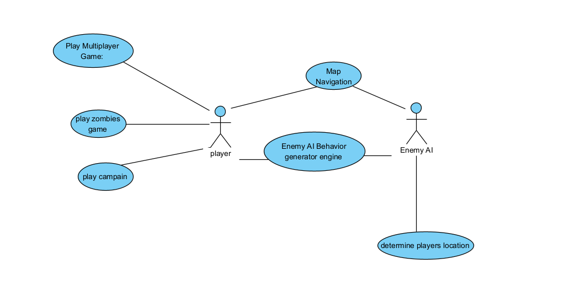

# Use Case 1: Navigate the Map

Actor: Player

Description: The player interacts with the in-game map or mini-map to navigate the game world, understand their position, and plan their movements efficiently.

# Use Case 2: Play Campaign

Actor: Player

Description: The player initiates the single-player campaign, where they immerse themselves in the game's narrative, follow mission objectives, and engage in a storyline-driven gaming experience.

# Use Case 3: Play Multiplayer

Actor: Player

Description: The player enters the multiplayer mode, participating in online matches with other players, selecting game modes, and engaging in competitive gameplay.

# Use Case 4: Play Zombies

Actor: Player

Description: The player enters the "Zombies" mode, where they confront waves of undead enemies and work to survive in this intense cooperative or solo gameplay mode.

Use Case 5: Interact with Enemy AI Behavior Generator Engine

Actor: Player

Description: The player engages with the in-game Enemy AI Behavior Generator Engine, a component responsible for generating the behavior of AI-controlled enemies. This interaction may involve configuring AI parameters or setting the difficulty level.

# Use Case 6: Navigate the Map (Enemy AI)

Actor: Enemy AI

Description: AI-controlled enemies interact with the map to navigate the game world strategically. They use this capability to plan their movements, find cover, and approach the player or objectives.

# Use Case 7: Access Enemy AI Generator Engine

Actor: Enemy AI

Description: AI-controlled enemies have access to the Enemy AI Generator Engine, a component responsible for determining their behavior and decision-making. This interaction enables them to receive instructions and updates on how to react to the player's actions.

# Use Case 8: Determine Player's Location (Enemy AI)

Actor: Enemy AI

Description: AI-controlled enemies continuously analyze and determine the player's location based on visual and auditory cues, allowing them to adapt their tactics, track the player's movements, and engage in combat effectively.

These use case descriptions provide a clear understanding of how different actors, including the player and enemy AI, interact with various game components and functionalities within "Call of Duty: Black Ops.